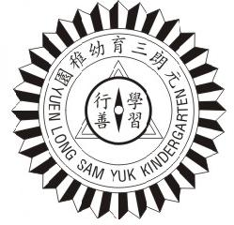
基督復臨安息日會 元朗三育幼稚園

YUEN LONG SAM YUK KINDERGARTEN OF SEVENTH-DAY ADVENTISTS
香港新界元朗青山公路元朗段265-267號(鄰近元朗廣場)
265-267 Castle Peak Road Yuen Long, Yuen Long, N.T. H.K.
TEL: 2476 3356 Fax: 2478 9952 E-mail: principal@ylsyk.edu.hk Web site: www.ylsyk.edu.hk

培養幼兒敬神愛人，建立自信，積極進取，發揮潛能，將來服務社群。

20________ - 20________
Application for wearing accessory

Student Name:_____________ Sex: _____M / F______
Studying Morning / Afternoon class

Appling for wearing accessory at school.

Reason:__________________________________________________________

Picture of the accessory:

- Send the filled form to ylsyk2016@outlook.com.
- The school reserves the rights of final decision.

